Name:
Class:
Date:
Gene Doping and the Future of Sports
STEP 4: ANSWER the short response questions & STEP 5: CREATE your ideal athlete

Step 4: Answer the short response questions
1. What is gene doping?

2. What is the difference between gene doping and gene therapy?

3. If the arrival of technology enables us to easily manipulate , we could give athletes supra-physiological amounts of key gene products, effectively creating superhuman athletes.
4. Given the context provided in question 3 and information from The Science Explorer article, how would you define supra-physiological?

5. What are two risks associated with gene doping?

6. Do you think athletes will accept the risks and proceed with gene doping? Why or why not?

7. Do you think gene doping will be good or bad for sports? Explain why.

Step 5: Create your ideal athlete
Imagine you can create an athlete for the upcoming Olympics. Customize your athlete by completing the following information and selecting his/her athletic attributes.

ATHLETE INFORMATION
Name (cannot be your name):
​
Gender:
​
Country:
​
Sport:
​
Body Type (Select one):
​
Tall Build & Low Strength | Medium Build & Medium Strength | Short build & High Strength
​
Athletic Attributes: Select one attribute from each box (next page).

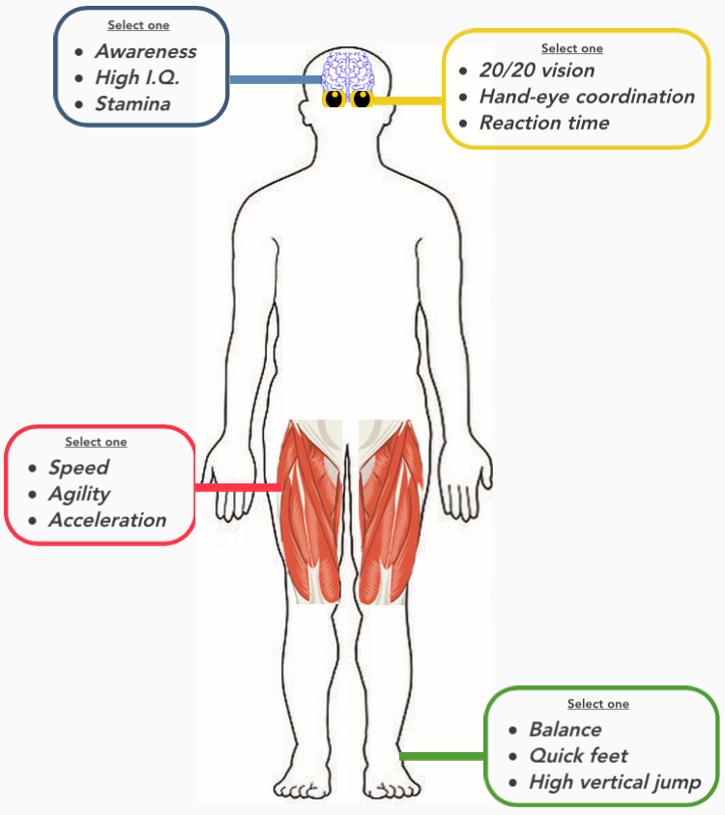

- List your four attributes (one from each box):

- Explain how you decided on your athlete’s body type and attributes.

- Provide a two to three sentence description of your athlete.

